11). Demonstrate virtualization by Installing Type -2 Hypervisor in your device, create and configure VM image with a Host Operating system (Either Windows/Linux).

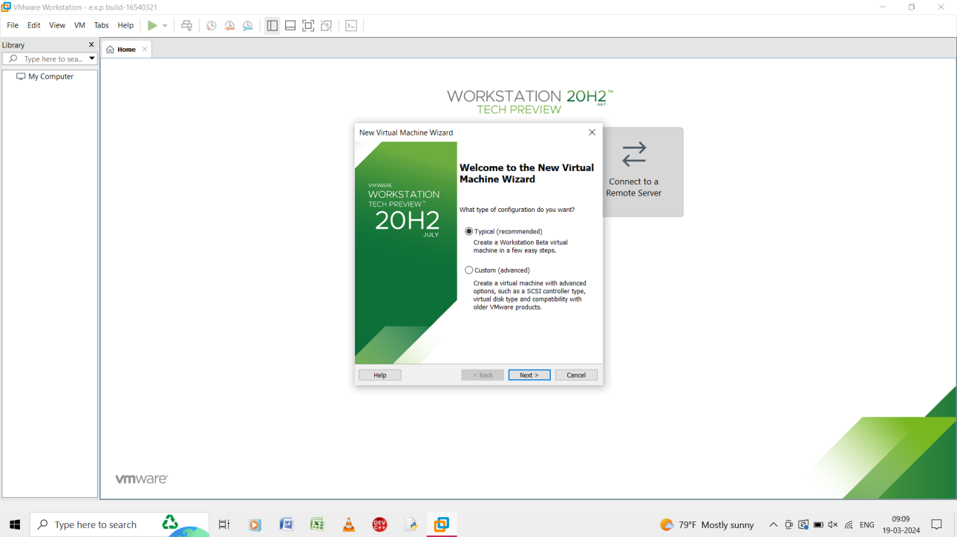

Step 1: create a new virtual machine and give typical as it is recommended.

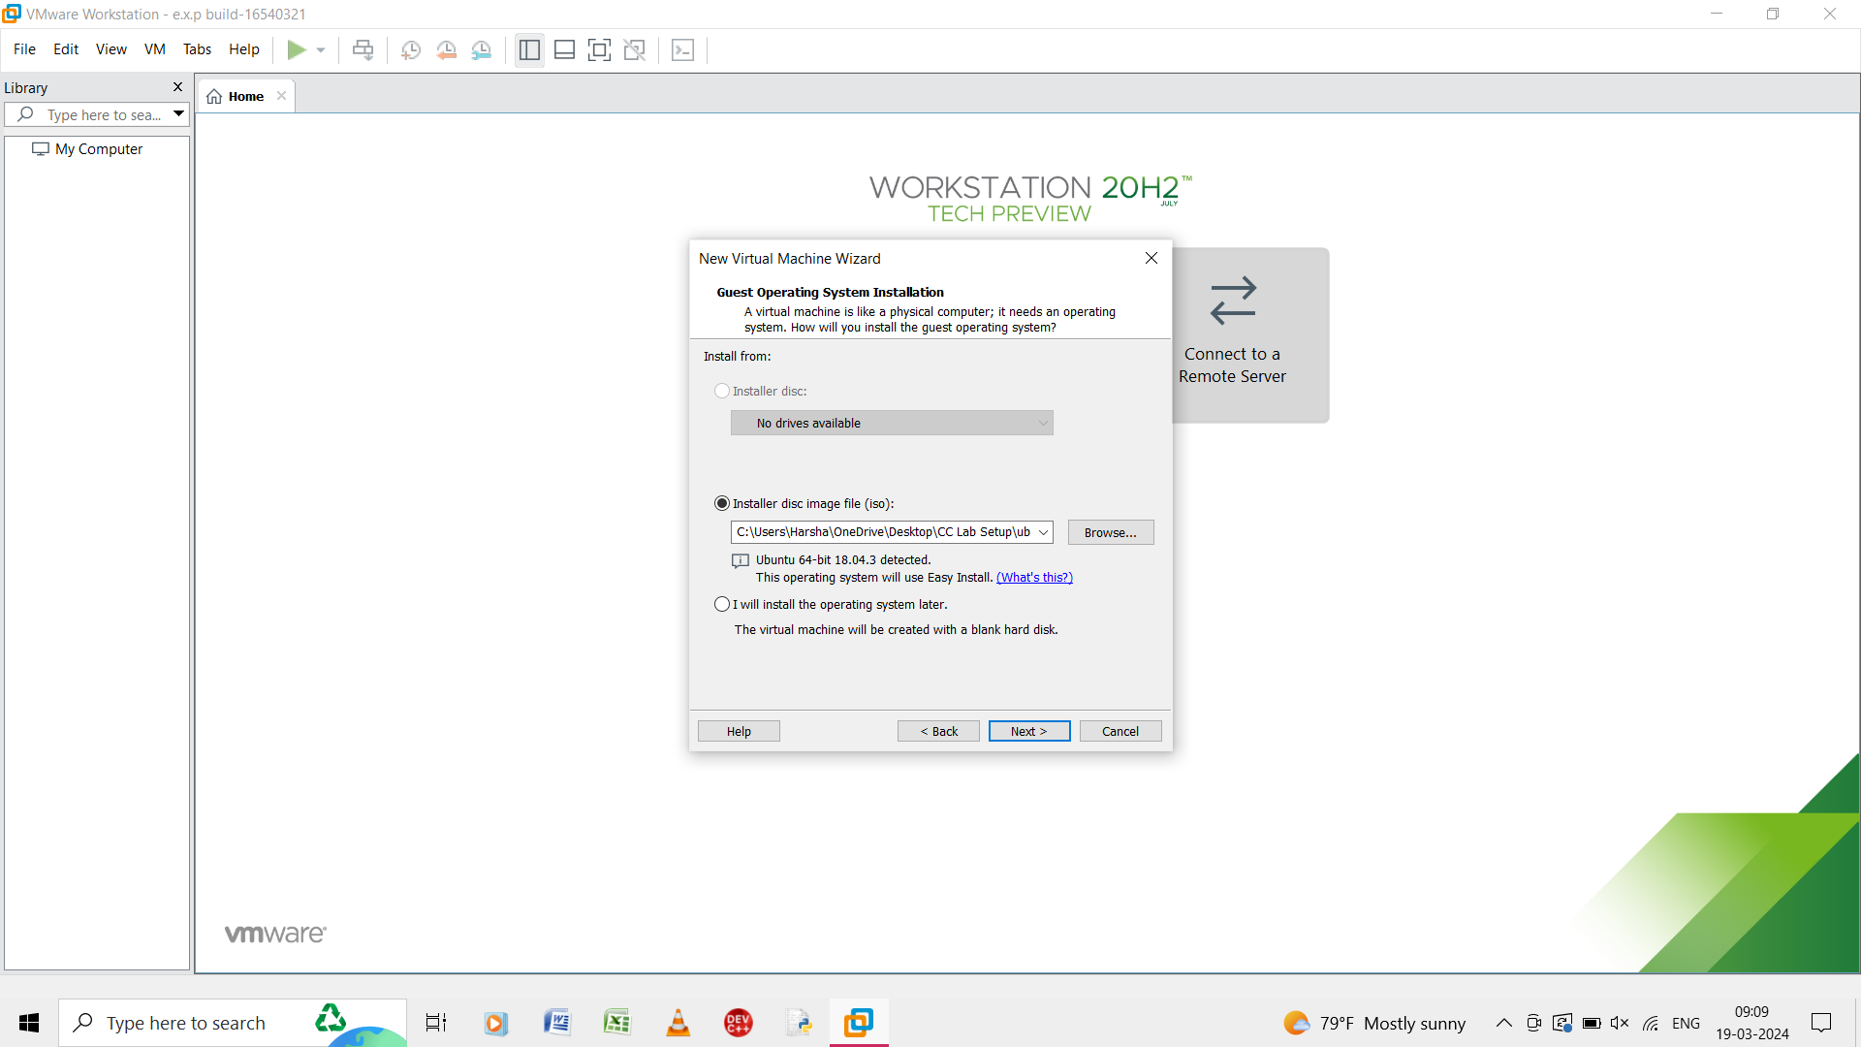

Step 2: select the installer disc image file and give ubuntu .

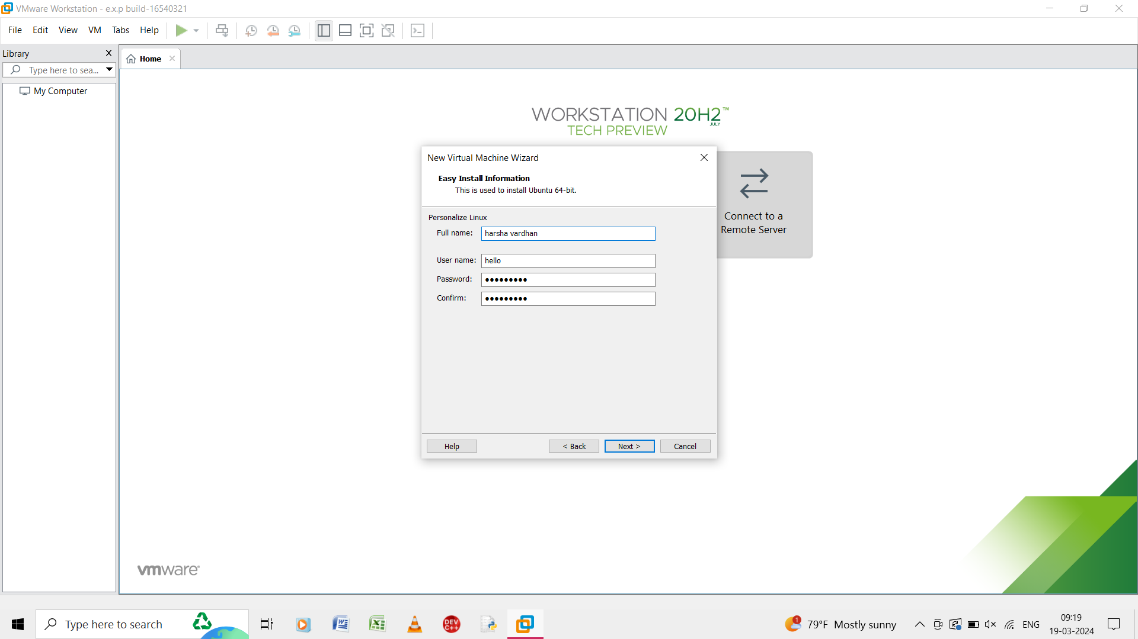

Step 3: in the new virtual machine give the inputs as, fullname, username, password, and confirm.

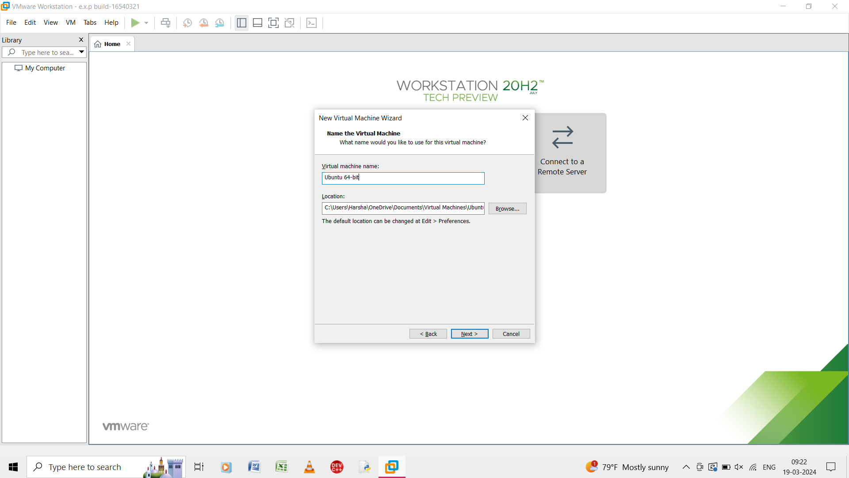

Step 4: give the name of the virtual machine and click next.

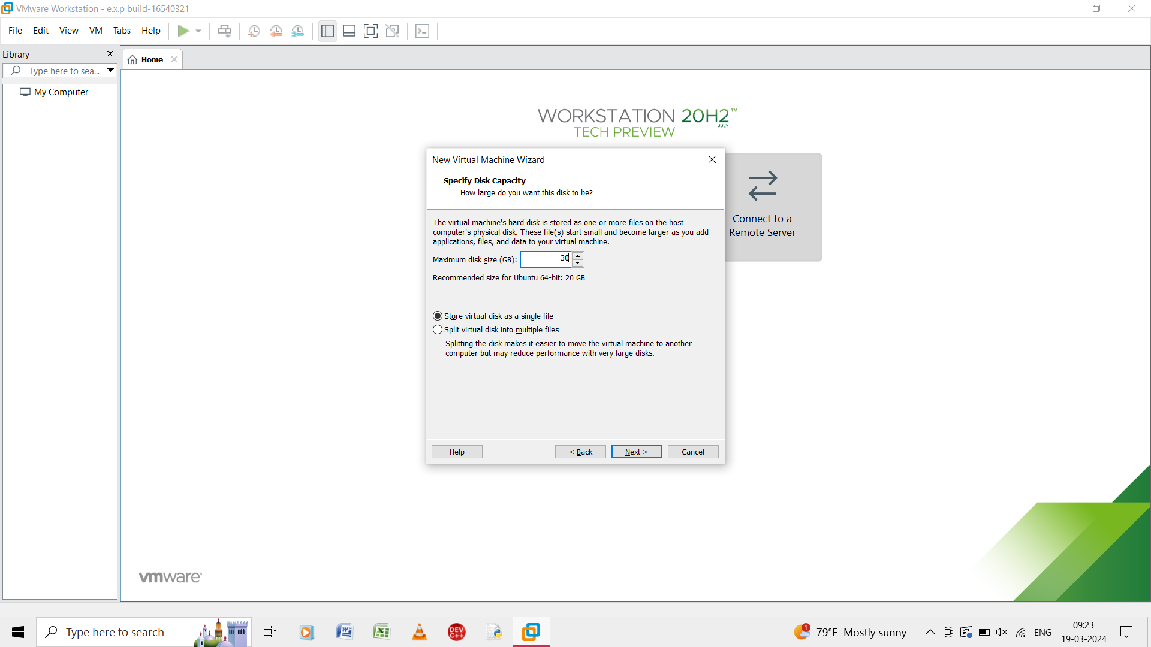

Step 5: give the maximum size of the diskand select the store virtual disk as a single file.

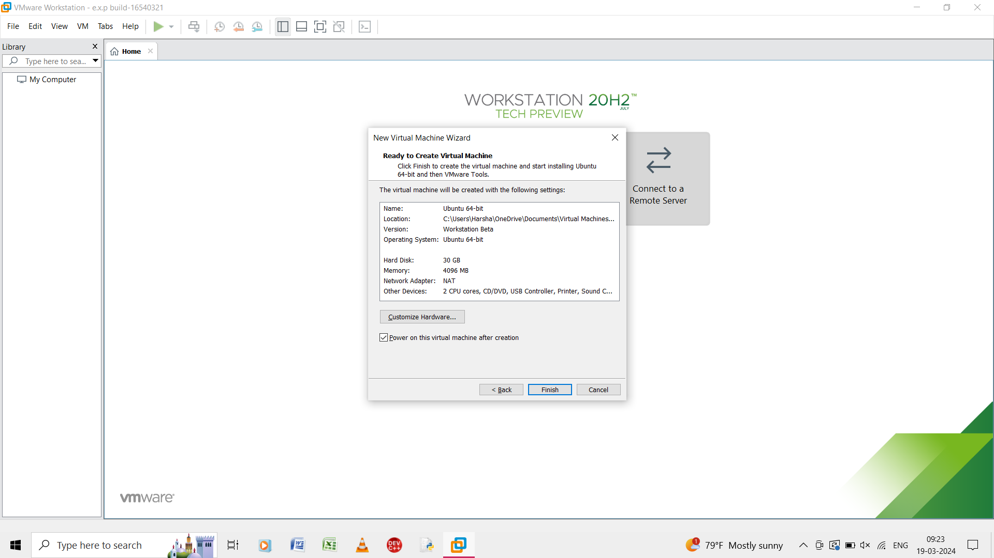

Step 6: it shows the summary of the virtual machine.

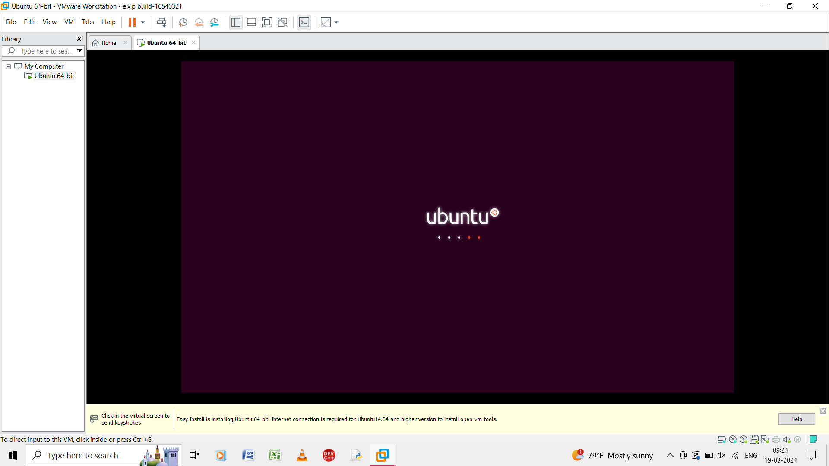

Step 7: the output of the virtual machine of linux is shown.